Single-Side Tangency
# Source: AI Source: Provided by: [Data Path: Persons Table -> ID Column: 1, Name_En Column: Motasem Essam] -> From: [ChatGPT] on [7/25/2026]
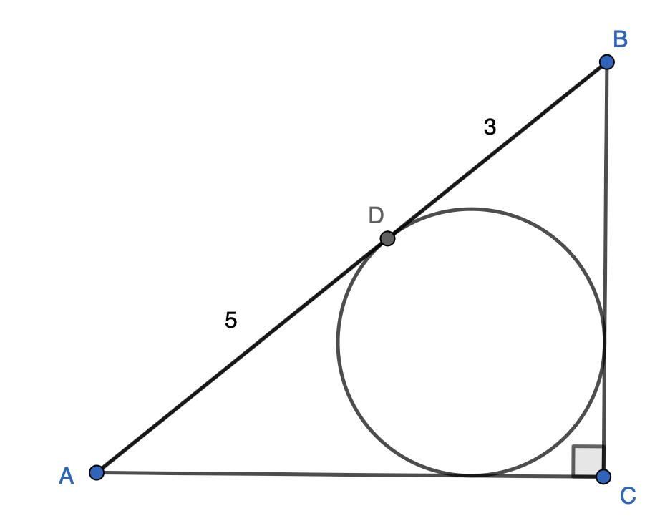
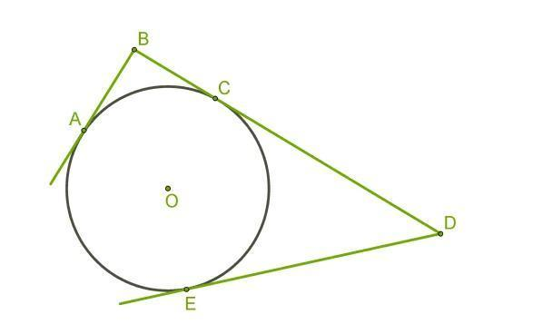
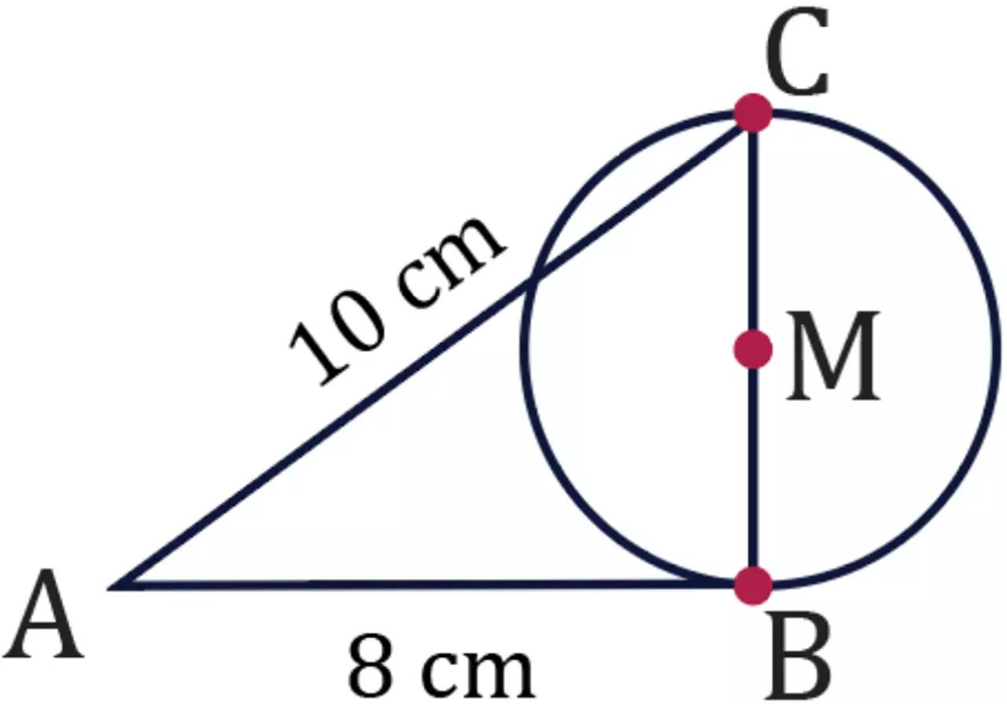
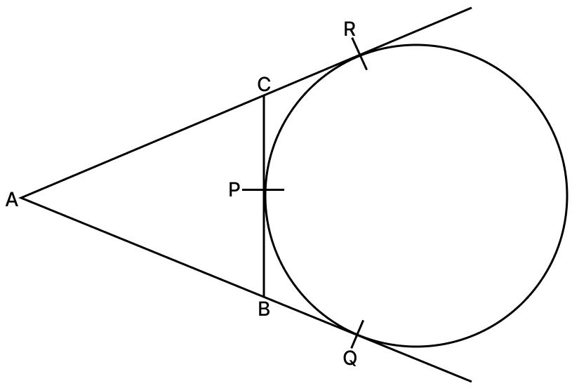

Definition
# Source: AI Source: Provided by: [Data Path: Persons Table -> ID Column: 1, Name_En Column: Motasem Essam] -> From: [ChatGPT] on [7/25/2026]
Single-Side Tangency is a type of Polygon–Circle Tangency in which a circle touches exactly one side of a polygon at one point, without crossing that side at the point of contact.
The common point between the circle and the polygon side is called the point of tangency or point of contact.
Unlike an inscribed circle, which is tangent to every side of a polygon, a single-side tangent circle touches only one polygon side.

Fundamental Concept
# Source: AI Source: Provided by: [Data Path: Persons Table -> ID Column: 1, Name_En Column: Motasem Essam] -> From: [ChatGPT] on [7/25/2026]
Consider a polygon with a circle tangent to one of its sides.
Let:
- $P$be the polygon.
- $AB$be the tangent side.
- $O$be the center of the circle.
- $T$be the point of tangency.
- $r$be the circle's radius.
Then:
$$\boxed{T∈\overset{‾}{AB}}$$
and the radius drawn to the point of tangency is perpendicular to the side:
$$\boxed{OT⊥AB}$$
Therefore, $OT$represents the shortest distance from the circle's center to the tangent side.

Main Parts
# Source: AI Source: Provided by: [Data Path: Persons Table -> ID Column: 1, Name_En Column: Motasem Essam] -> From: [ChatGPT] on [7/25/2026]
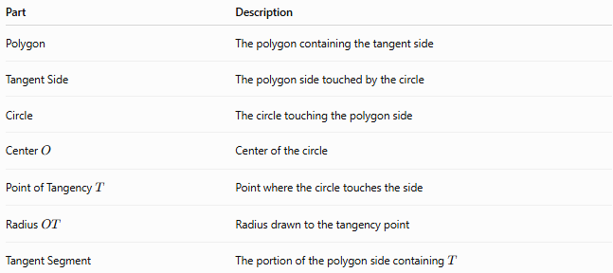
Part | Description
Polygon | The polygon containing the tangent side
Tangent Side | The polygon side touched by the circle
Circle | The circle touching the polygon side
Center $O$ | Center of the circle
Point of Tangency $T$ | Point where the circle touches the side
Radius $OT$ | Radius drawn to the tangency point
Tangent Segment | The portion of the polygon side containing $T$

Defining Properties

1-Exactly One Tangent Side
# Source: AI Source: Provided by: [Data Path: Persons Table -> ID Column: 1, Name_En Column: Motasem Essam] -> From: [ChatGPT] on [7/25/2026]
The circle is tangent to exactly one polygon side:
$$\boxed{\text{Number of tangent sides}=1}$$
The other polygon sides are not tangent to the circle.

2-Exactly One Point of Tangency
# Source: AI Source: Provided by: [Data Path: Persons Table -> ID Column: 1, Name_En Column: Motasem Essam] -> From: [ChatGPT] on [7/25/2026]
The circle and the tangent side share exactly one point:
$$\boxed{\overset{‾}{AB}∩C=\left\{T\right\}}$$
where $C$represents the circle.

3-Perpendicular Radius
# Source: AI Source: Provided by: [Data Path: Persons Table -> ID Column: 1, Name_En Column: Motasem Essam] -> From: [ChatGPT] on [7/25/2026]
The radius drawn from the center to the tangency point is perpendicular to the polygon side:
$$\boxed{OT⊥AB}$$
This is the fundamental property of tangency.

4-The Tangency Point Lies on the Side
# Source: AI Source: Provided by: [Data Path: Persons Table -> ID Column: 1, Name_En Column: Motasem Essam] -> From: [ChatGPT] on [7/25/2026]
For the tangency to occur on the polygon side itself:
$$\boxed{T∈\overset{‾}{AB}}$$
The circle may touch the extension of a side without touching the actual polygon side; that is a different configuration.

Distance from the Center to the Side
# Source: AI Source: Provided by: [Data Path: Persons Table -> ID Column: 1, Name_En Column: Motasem Essam] -> From: [ChatGPT] on [7/25/2026]
Because $AB$is tangent to the circle:
$$\boxed{d\left(O , AB\right)=r}$$
where:
- $d\left(O , AB\right)$is the perpendicular distance from $O$to side $AB$.
- $r$is the radius.
Thus:
$$\boxed{OT=r}$$

Tangency Diagram
# Source: AI Source: Provided by: [Data Path: Persons Table -> ID Column: 1, Name_En Column: Motasem Essam] -> From: [ChatGPT] on [7/25/2026]
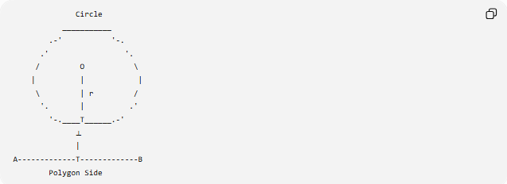
Circle
___________
.-' '-.
.' '.
/ O \
| | |
\ | r /
'. | .'
'-.____T______.-'
⟂
|
A-------------T-------------B
Polygon Side
The essential relationship is:
$$\boxed{OT⊥AB}$$

Position of the Circle
# Source: AI Source: Provided by: [Data Path: Persons Table -> ID Column: 1, Name_En Column: Motasem Essam] -> From: [ChatGPT] on [7/25/2026]
Single-side tangency can occur with the circle positioned in different ways relative to the polygon.

1-Circle Inside the Polygon
# Source: AI Source: Provided by: [Data Path: Persons Table -> ID Column: 1, Name_En Column: Motasem Essam] -> From: [ChatGPT] on [7/25/2026]
The circle lies inside the polygon and touches one side.
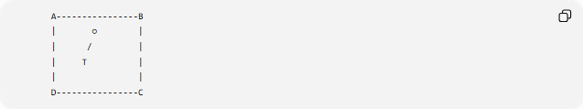
A----------------B
| ○ |
| / |
| T |
| |
D----------------C
Only one polygon side is tangent to the circle.

2-Circle Outside the Polygon
# Source: AI Source: Provided by: [Data Path: Persons Table -> ID Column: 1, Name_En Column: Motasem Essam] -> From: [ChatGPT] on [7/25/2026]
A circle can also touch one polygon side from the exterior.

A----------------T----------------B
)
( Circle
)
The exact configuration depends on the polygon and the circle's position.

Types by Circle Position
# Source: AI Source: Provided by: [Data Path: Persons Table -> ID Column: 1, Name_En Column: Motasem Essam] -> From: [ChatGPT] on [7/25/2026]
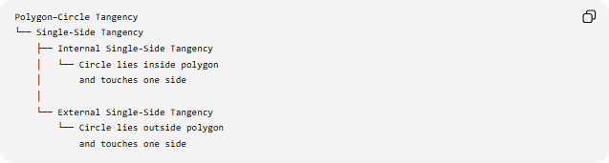
Polygon–Circle Tangency
└── Single-Side Tangency
├── Internal Single-Side Tangency
│ └── Circle lies inside polygon
│ and touches one side
│
└── External Single-Side Tangency
└── Circle lies outside polygon
and touches one side
The primary defining feature remains the same: only one polygon side is tangent to the circle.

Single-Side Tangency vs Full Polygon Tangency
# Source: AI Source: Provided by: [Data Path: Persons Table -> ID Column: 1, Name_En Column: Motasem Essam] -> From: [ChatGPT] on [7/25/2026]
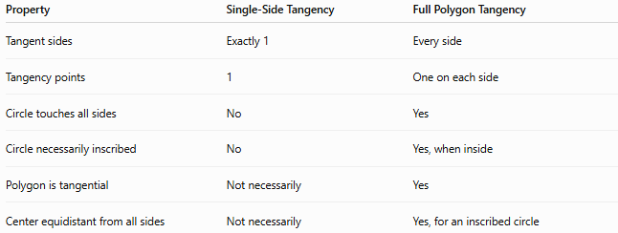
Property | Single-Side Tangency | Full Polygon Tangency
Tangent sides | Exactly 1 | Every side
Tangency points | 1 | One on each side
Circle touches all sides | No | Yes
Circle necessarily inscribed | No | Yes, when inside
Polygon is tangential | Not necessarily | Yes
Center equidistant from all sides | Not necessarily | Yes, for an inscribed circle
For example, a circle touching one side of a pentagon is not an inscribed circle merely because it touches a polygon side.

Single-Side Tangency vs Secant Intersection
# Source: AI Source: Provided by: [Data Path: Persons Table -> ID Column: 1, Name_En Column: Motasem Essam] -> From: [ChatGPT] on [7/25/2026]
A polygon side can interact with a circle in three basic ways:
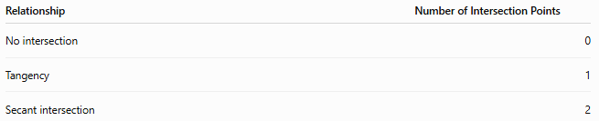
Relationship | Number of Intersection Points
No intersection | 0
Tangency | 1
Secant intersection | 2
For tangency:
$$\boxed{1\text{ common point}}$$
For a secant:
$$\boxed{2\text{ common points}}$$

Important Geometric Relationships
# Source: AI Source: Provided by: [Data Path: Persons Table -> ID Column: 1, Name_En Column: Motasem Essam] -> From: [ChatGPT] on [7/25/2026]
Radius–Side Relationship
$$\boxed{OT⊥AB}$$
Center-to-Side Distance
$$\boxed{d\left(O , AB\right)=r}$$
Tangency Point
$$\boxed{T∈\overset{‾}{AB}}$$
Shortest Distance
The perpendicular segment $OT$is the shortest distance from the circle's center to the side.

Example
# Source: AI Source: Provided by: [Data Path: Persons Table -> ID Column: 1, Name_En Column: Motasem Essam] -> From: [ChatGPT] on [7/25/2026]
Suppose a circle has radius:
$$r=5\text{ cm}$$
and touches polygon side $AB$at $T$.
Then the perpendicular distance from the circle's center $O$to $AB$is:
$$OT=r$$
Therefore:
$$\boxed{OT=5\text{ cm}}$$
If the circle touches no other polygon side, the configuration is single-side tangency.

Coordinate Geometry
# Source: AI Source: Provided by: [Data Path: Persons Table -> ID Column: 1, Name_En Column: Motasem Essam] -> From: [ChatGPT] on [7/25/2026]
Suppose the polygon side lies on the line:
$$Ax+By+C=0$$
and the circle has center:
$$O=\left(h , k\right)$$
and radius $r$.
The circle is tangent to the side when:
$$\boxed{\frac{∣Ah+Bk+C∣}{\sqrt{A^{2}+B^{2}}}=r}$$
The perpendicular projection of $O$onto the line gives the tangency point $T$.
However, for polygon-side tangency, $T$must also lie on the finite side segment, not merely on the infinite supporting line.

Important Distinction: Side vs Side Extension
# Source: AI Source: Provided by: [Data Path: Persons Table -> ID Column: 1, Name_En Column: Motasem Essam] -> From: [ChatGPT] on [7/25/2026]
This distinction is important.
Suppose $AB$is a polygon side.
Tangency to the Side
$$\boxed{T∈\overset{‾}{AB}}$$
This is genuine single-side tangency.
Tangency to the Side's Extension
$$\boxed{T∉\overset{‾}{AB}}$$
but $T$lies on the infinite line containing $AB$.
In this case, the circle is tangent to the supporting line of the side, but not to the actual polygon side segment.

Applications
# Source: AI Source: Provided by: [Data Path: Persons Table -> ID Column: 1, Name_En Column: Motasem Essam] -> From: [ChatGPT] on [7/25/2026]
Single-side polygon–circle tangency appears in:
- Geometric constructions
- CAD and technical drawing
- Mechanical design
- Circular components positioned against straight edges
- Packaging and layout design
- Computer graphics
- Collision and contact detection
- Engineering models
- Optimization problems involving distances from circles to polygon boundaries

Key Points
# Source: AI Source: Provided by: [Data Path: Persons Table -> ID Column: 1, Name_En Column: Motasem Essam] -> From: [ChatGPT] on [7/25/2026]
- Single-Side Tangency occurs when a circle touches exactly one side of a polygon.
- There is exactly one point of tangency on that side.
- The tangency point belongs to the actual side segment:
$$\boxed{T∈\overset{‾}{AB}}$$
- The radius to the tangency point is perpendicular to the side:
$$\boxed{OT⊥AB}$$
- The center-to-side distance equals the radius:
$$\boxed{d\left(O , AB\right)=r}$$
- A circle tangent to only one polygon side is not necessarily an inscribed circle.
- Tangency to the extension of a side is different from tangency to the actual polygon side.
- An inscribed circle is a special case of polygon–circle tangency in which the circle touches every side.

Conclusion
# Source: AI Source: Provided by: [Data Path: Persons Table -> ID Column: 1, Name_En Column: Motasem Essam] -> From: [ChatGPT] on [7/25/2026]
Single-Side Tangency describes the simplest form of polygon–circle tangency: a circle touches exactly one polygon side at exactly one point. The defining geometric property is the perpendicular relationship between the radius and the tangent side:
$$\boxed{OT⊥AB}$$
with:
$$\boxed{OT=r}$$
and:
$$\boxed{T∈\overset{‾}{AB}}$$
It should be distinguished from an inscribed circle, which is tangent to every side of the polygon.

